Milestone 4

Completed Items

Completed for milestone 4:

Revised milestone. Sorted with latest Milestone moved to front and older ones moved to the back.

Completed documentation and screenshots (forms, table) for milestone 3.

Added to milestone 3 what was still needed to be done (feedback).

Added Client-Side Validation: Validation script and regular expressions for all email and password input fields.

Added open-source JavaScript for preventing right clicks on page with mouse.

Testing form validation with and without javascript.

Form Testing

FORM on page: CONTENT

Field ID Data Format or RegExp Explanation

personal_name /([.*+?^=!:${}()|[\]\/\\])/ Restricts entry to numbers or letters only.

email_address /^(([a-zA-Z]|[0-9])|([-]|[_]|[.]))+[@](([a-zA-Z0-9])|([-])){2,63}[.](([a-zA-Z0-9]){2,63})+$/gi

Restrict email portion before “at” and after to characters a-z, A-Z, 0-9, dash, underscore and period. The last portion, the Top Level Domain, is limited to a-z, A-Z and 0-9 only.

FORM on page: REGISTRATION

Field ID Data Format or RegExp Explanation

userName /([.*+?^=!:${}()|[\]\/\\])/ Restricts entry to numbers or letters only.

Password /([a-z][A-Z][0-9])/ Password is limited to letters and numbers only.

password2 Text. The password string in this field is compared to password (must match)

email /^(([a-zA-Z]|[0-9])|([-]|[_]|[.]))+[@](([a-zA-Z0-9])|([-])){2,63}[.](([a-zA-Z0-9]){2,63})+$/gi

Restrict email portion before “at” and after to characters a-z, A-Z, 0-9, dash, underscore and period. The last portion, the Top Level Domain, is limited to a-z, A-Z and 0-9 only.

FORM on page: CONTENT

Text. No ID or restrictions.

FORM on page: NEWS

Text. No ID or restrictions.

Milestone 4

Form Testing

Test form

TEST DOCUMENTATION for FORM on page: registration.html

FIELD LEVEL TESTING

Field ID Problem Improvements

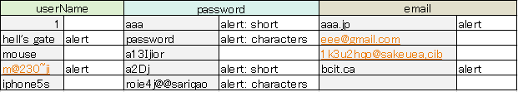

FORM LEVEL TESTING

Field ID Problem Improvements

JavaScript third party widget

We add a function that user cannot do right click on web sites. Our site would use pictures which have copyright that prohibiting to do right click protects.

COMP1536 Website Development Project: Milestone 3

Miscellaneous Documentation

Project work URL: <https://github.com/jestertan/Group-Project>

List of items completed:

* HTML for all pages
* External CSS for HTML styling
* Addition of functional forms in HTML using provided asp page at webdevfoundations.net/scripts/formdemo.asp

Additional work required for this milestone (from feedback):

* Complete milestone three using feedback on D2L
* Correction of seven website validation errors
* Revising base.css to remove two validation errors
* Create a URL link for the website

Key issues encountered in website build for milestone three:

* None

Deviations from proposal and design:

* None

COMP1536 Website Development Project: Milestone 3

AB Test

Background image



Background no image

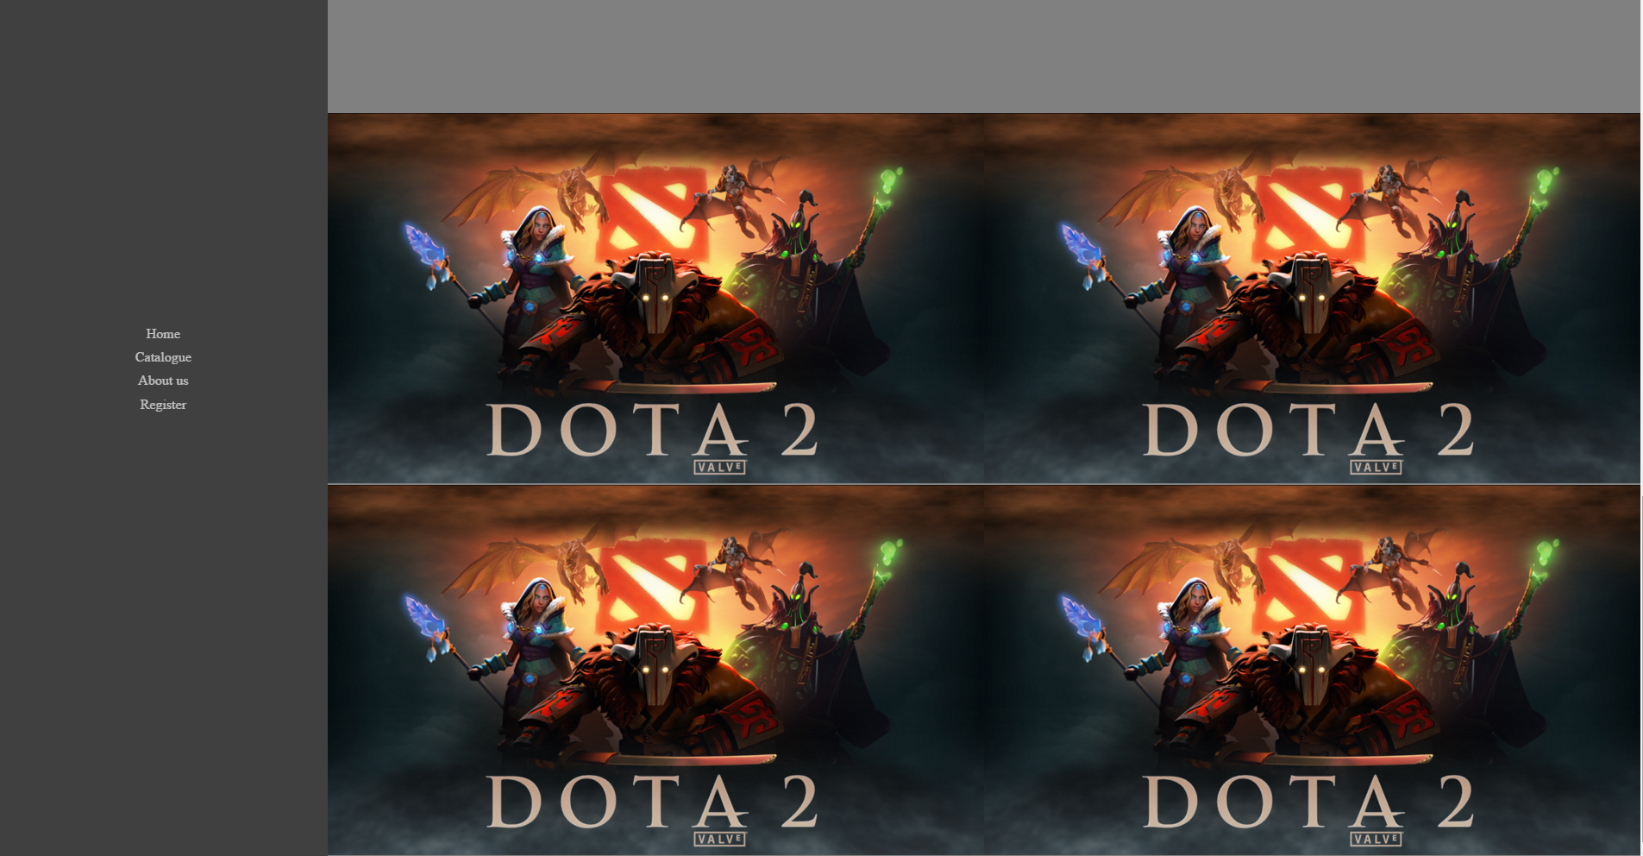

Background image

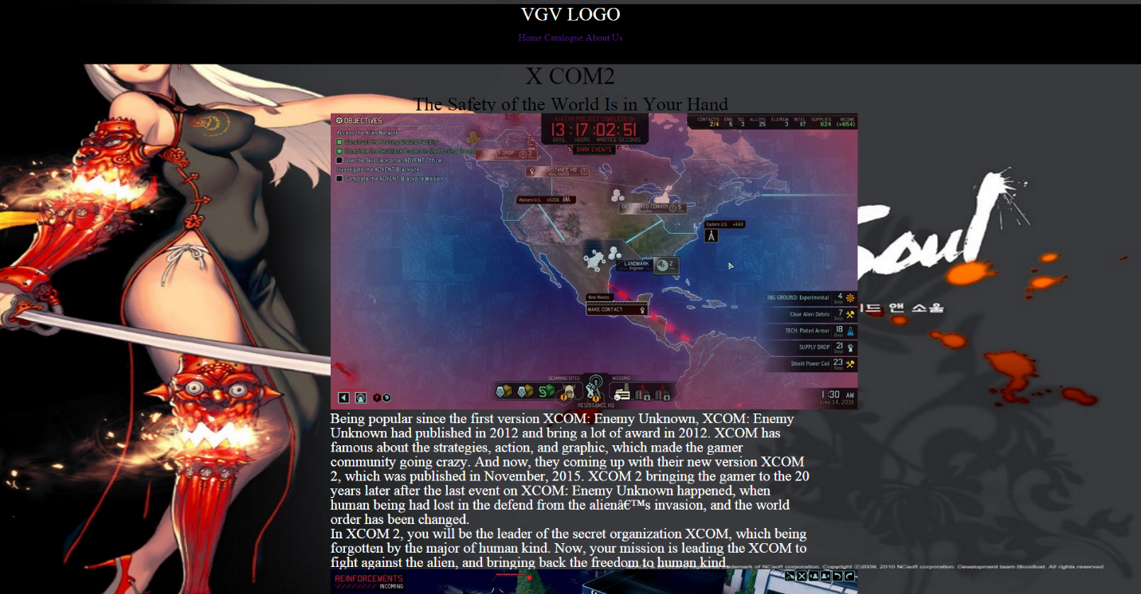

Background no image

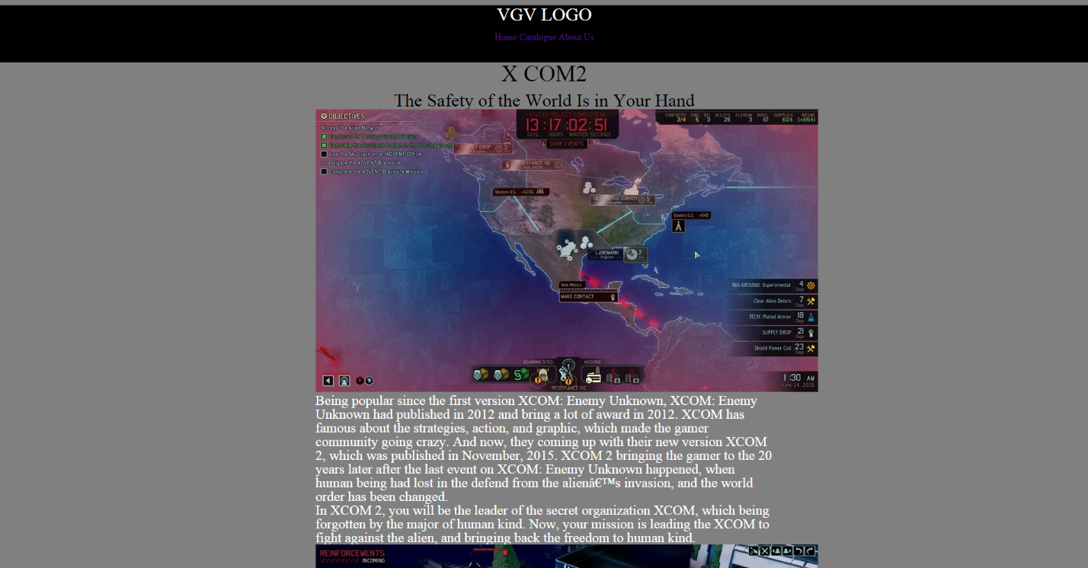

Background image

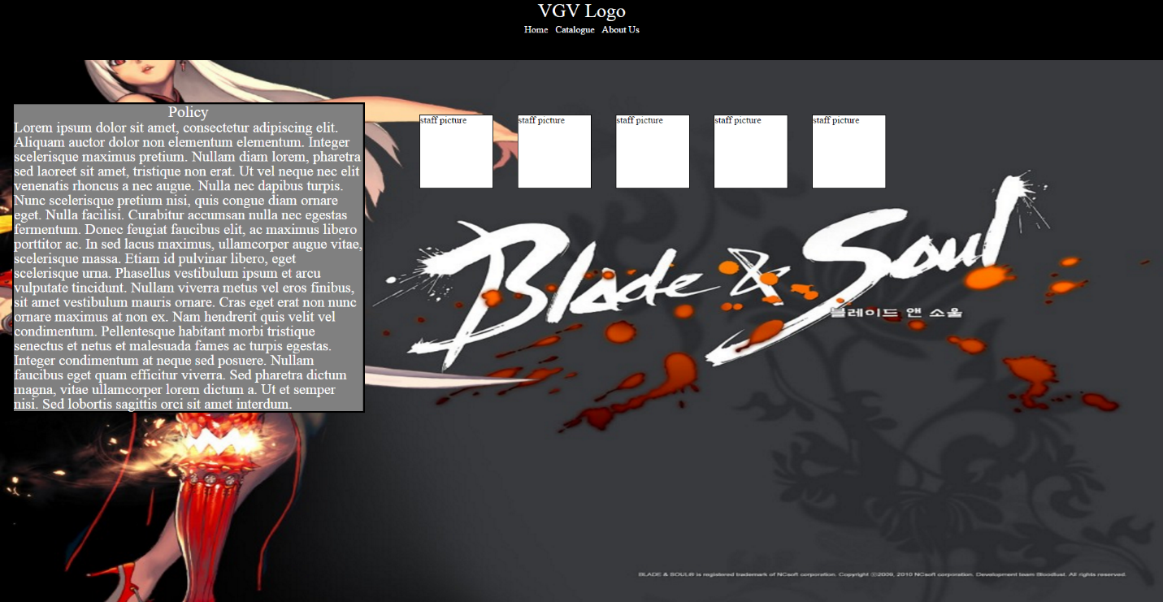

Background no image

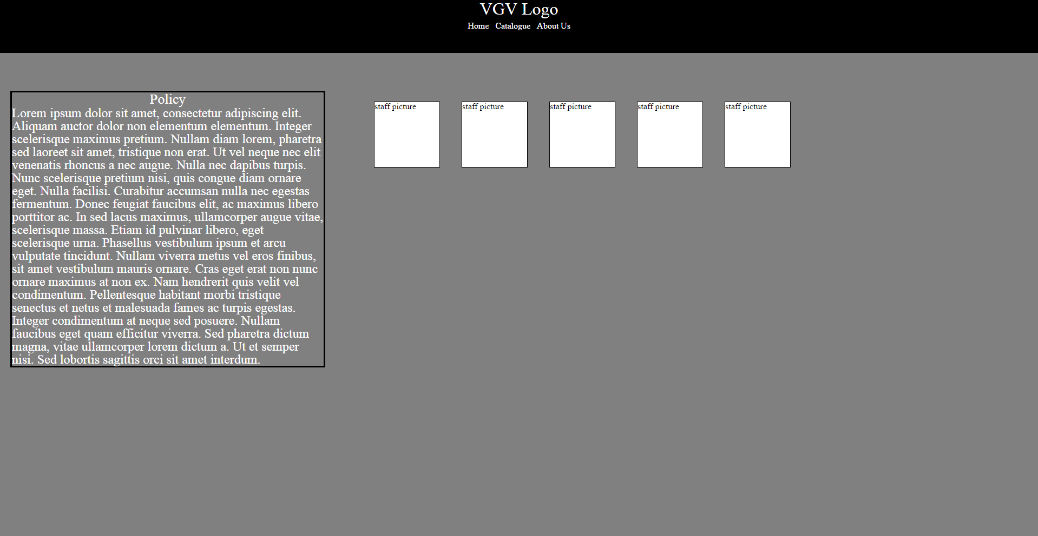

Background image

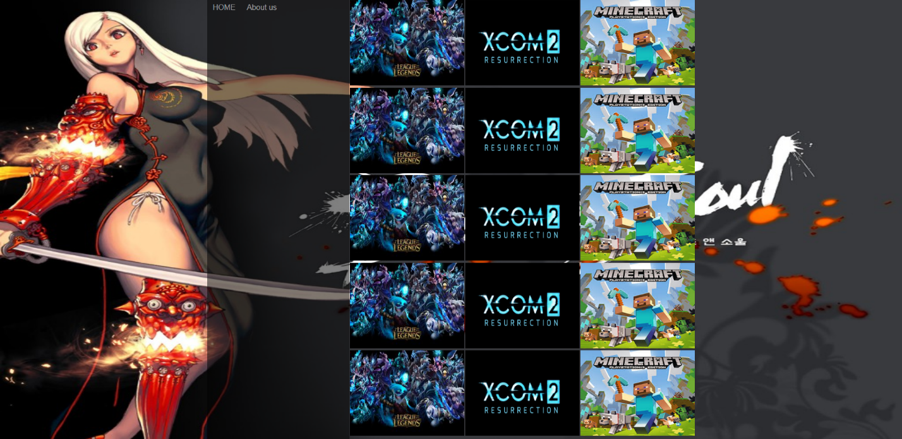

Background no image

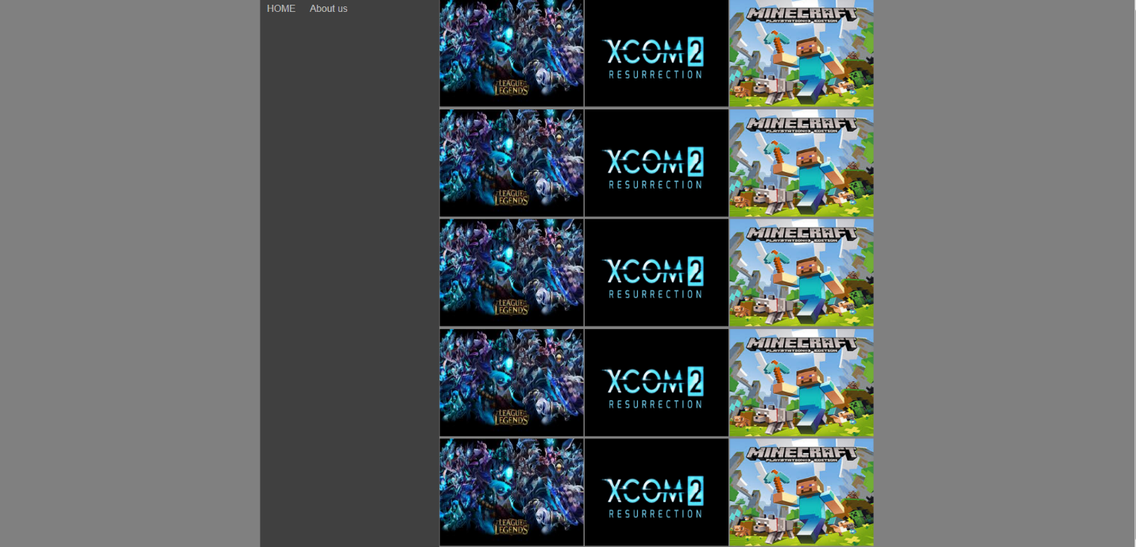

Background image should be used on all web pages.

Screen captures

Front Page

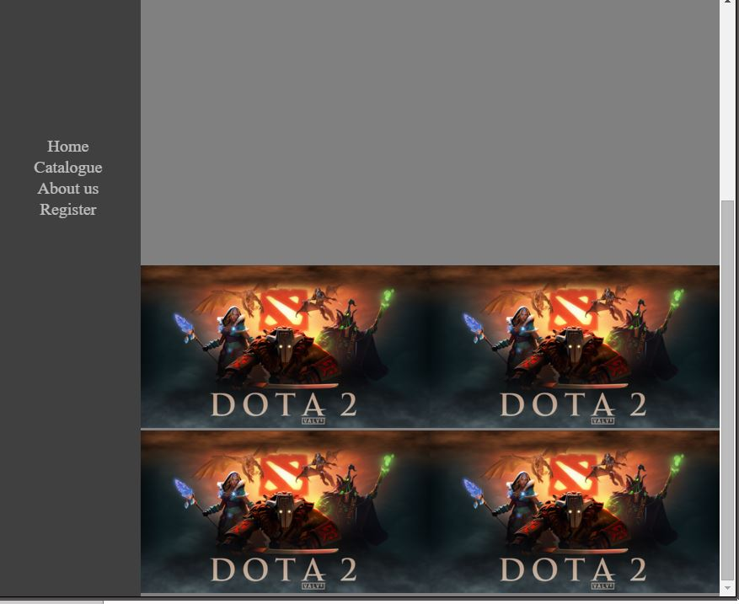

Screen Captures

Table

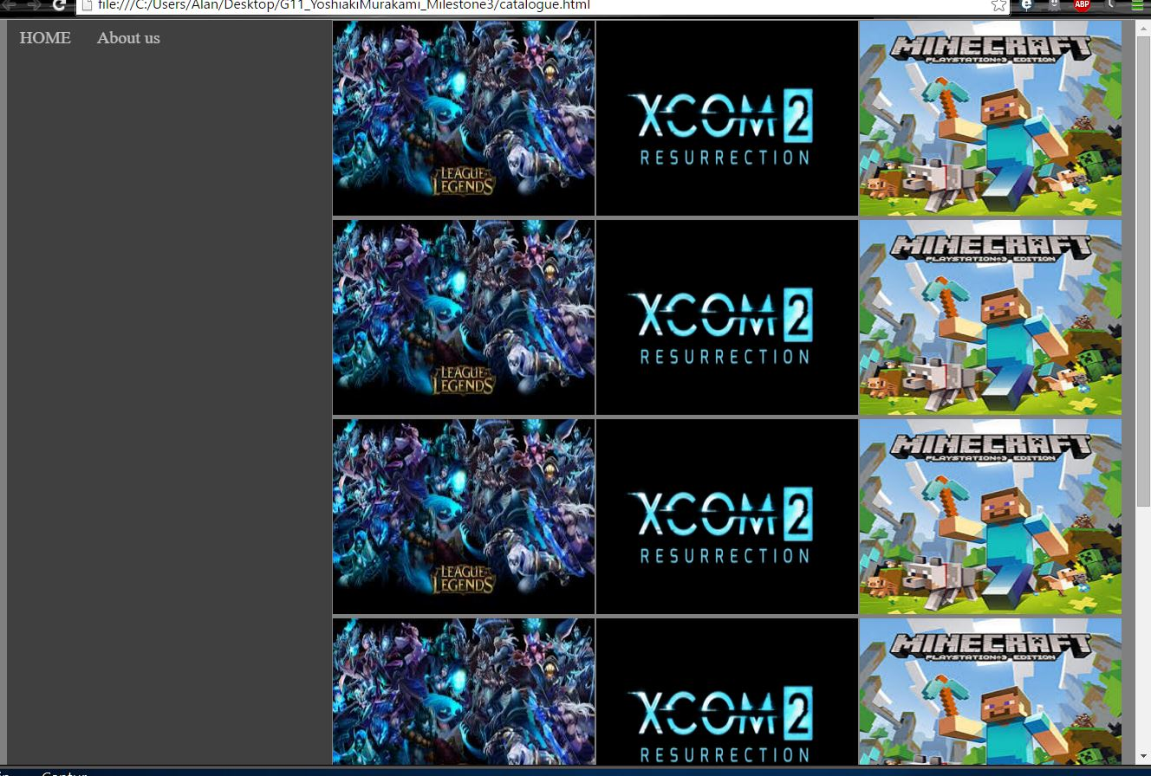

Screen Captures

Form: News page

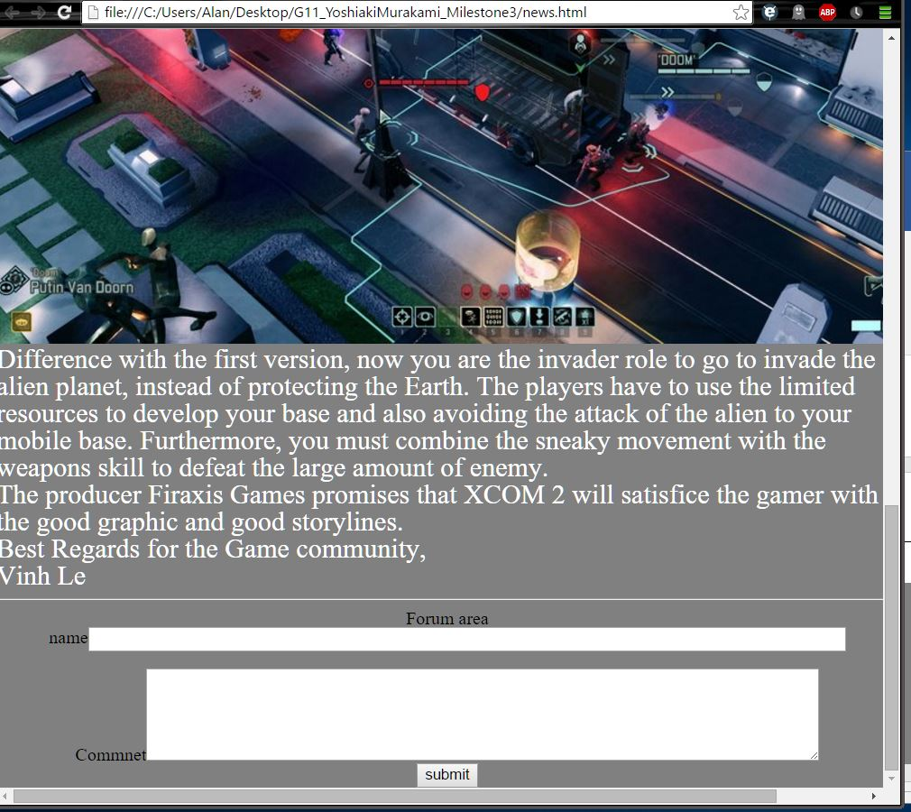

Sscreen Captures

Form: Content page

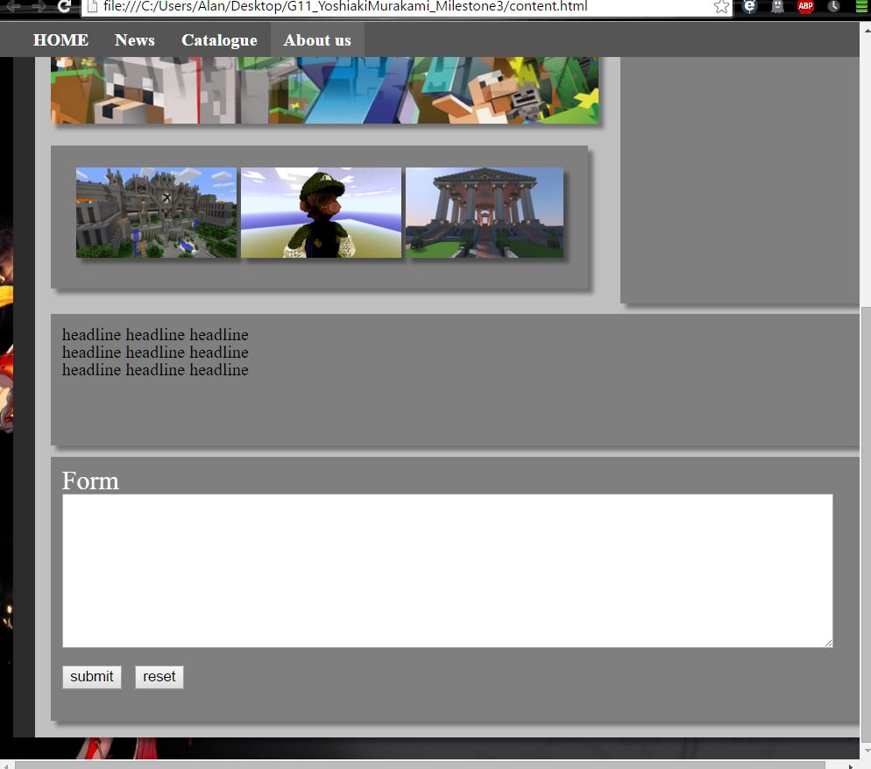

Screen Captures

Form: Registration

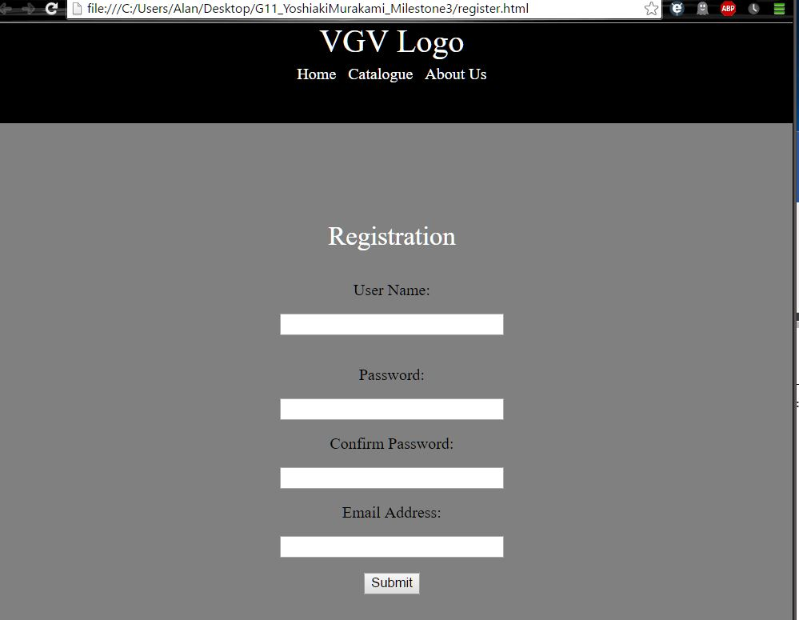

COMP1536 Website Development Project: Milestone 2

Sitemap



Page Layout Details

COMP1536 Website Development Project

Website design practices and reasons

-Proper choice of colour for contrast (black with white for text) and accessibility

-Balanced selection of images to aid navigation and make the site visually appealing

-Content arranged into grid design to keep content organized

-Following coding conventions and validating our code through w3C for compatibility

-Well researched and recent content to attract and keep visitor traffic

Wireframe: Catalogue Detail Page

Two Column Fluid

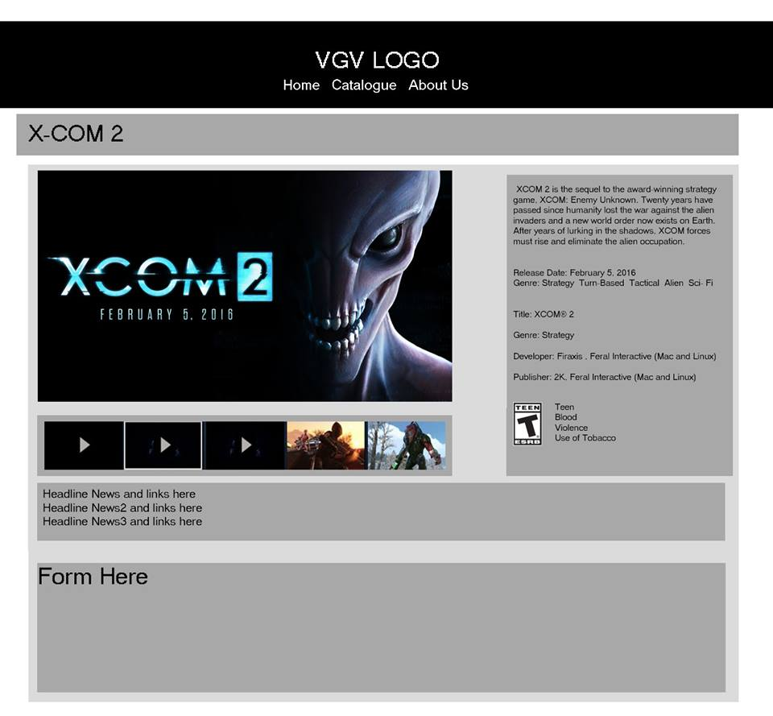

Catalog Index

4 Column Fluid

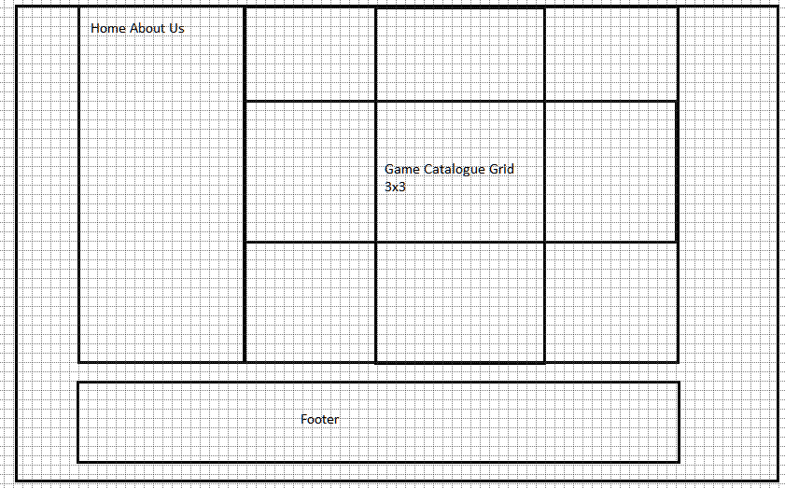

Wireframe: News page

One Column Fluid

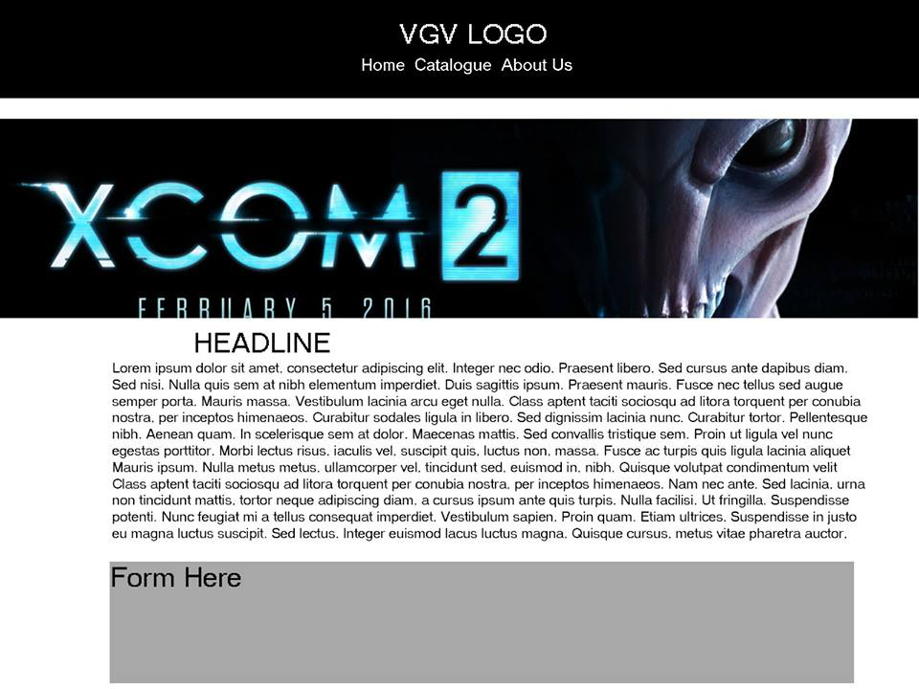

Wireframe: Policy and Staff Page

Two Column Fluid

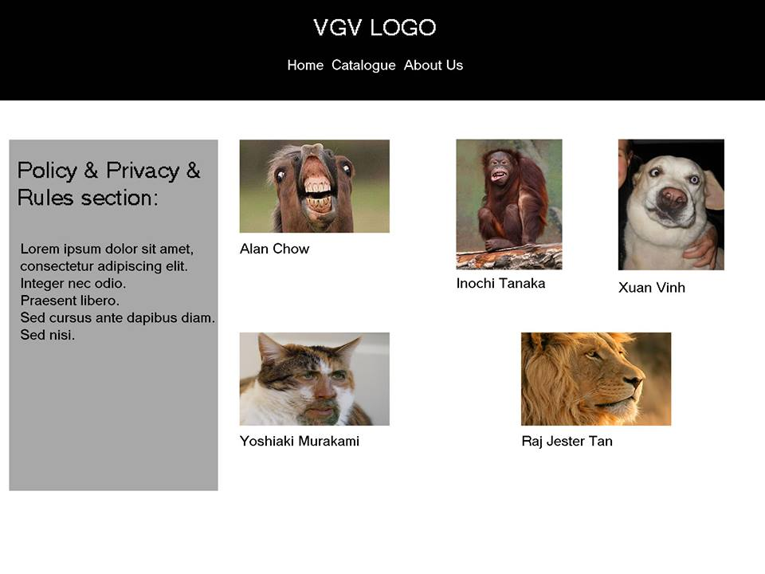

Wireframe: Top Page

Three Column Fluid



Wireframe: Registration Page

One Column Fluid

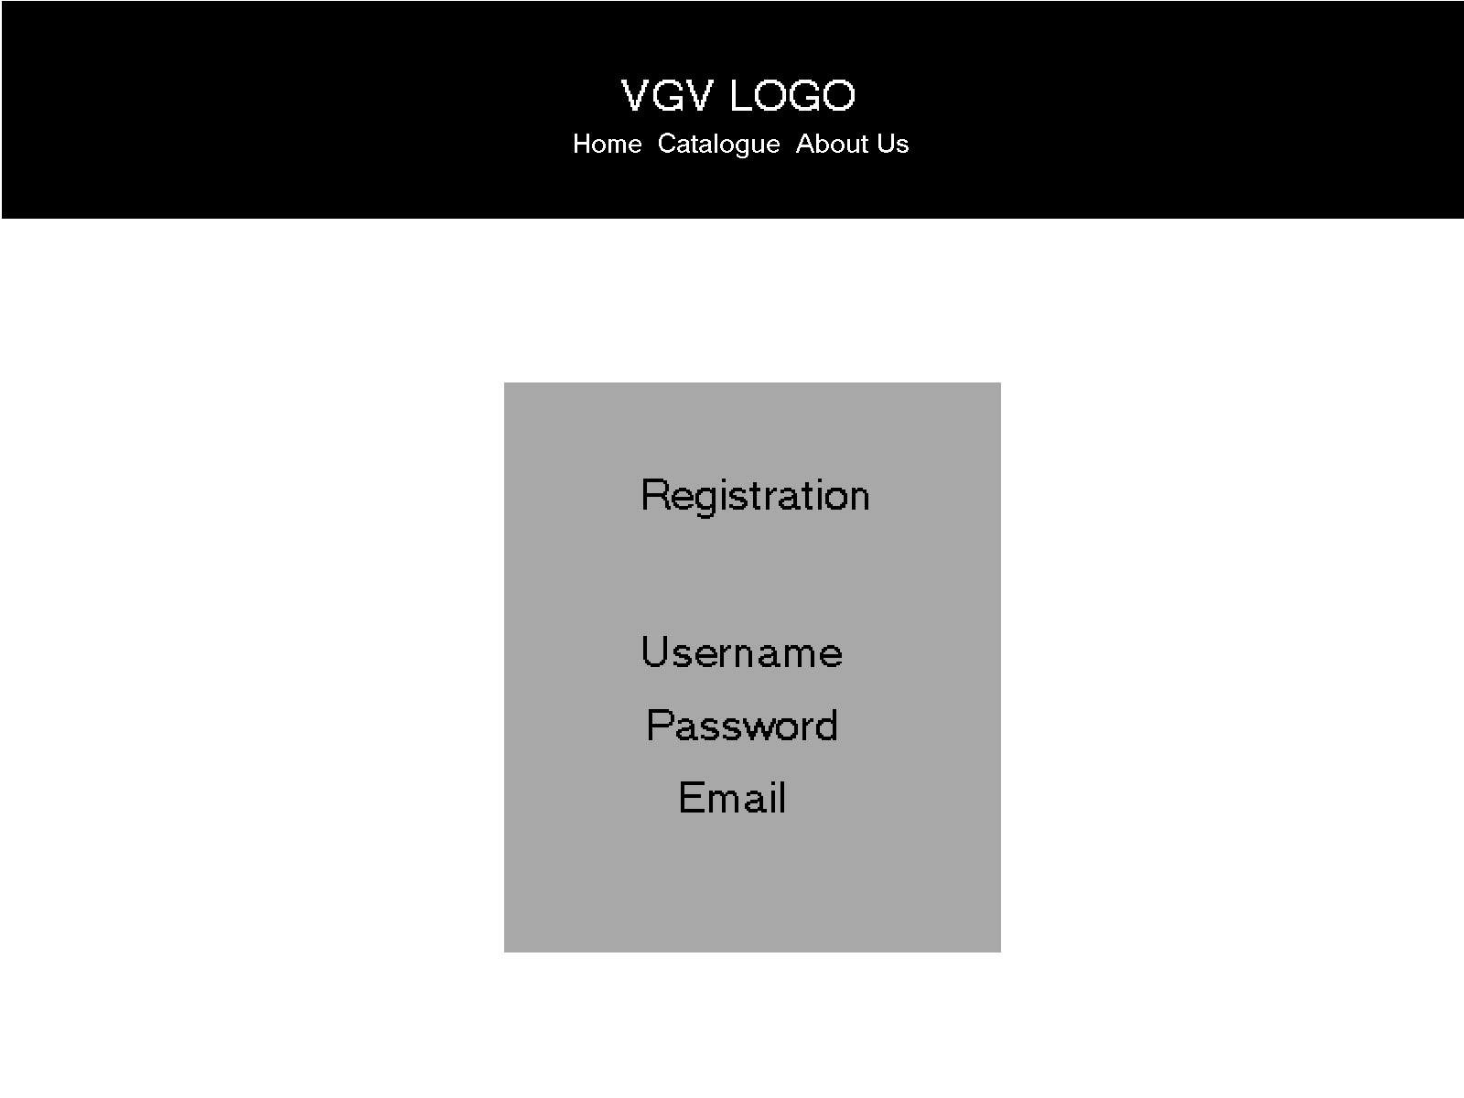

Wireframe: Thank you page



Print Layout

Index

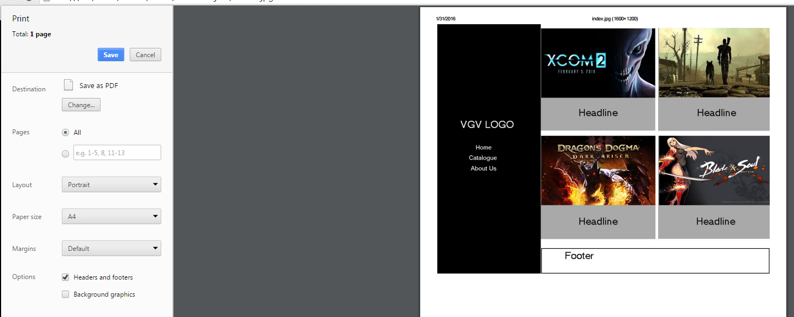

COMP1536 Website Development Project: Milestone 1

Revised Project Proposal

Purpose, needs served

The purpose of our website is to deliver up to date and interesting PC gaming news, PC game reviews and coverage of the latest releases. Our website will serve the needs of gamers who want coverage of the latest games and diverse viewpoints on new developments in the industry.

Goals

Communication and community. We want to create a community for gamers and provide them with important and relevant information from the gaming industry as a service.

Target Audience

This website will be built for those who are in the 18 and older age group, and read English proficiently.

Accomplishments Needed

The website needs to provide up to date material in the PC gaming industry in a form accessible from both computers and mobile devices. In addition, it must provide a platform for visitors to interact and form a community. Finally, the website must also have a visually appealing design balancing selected images with our chosen colour scheme.

Content

The website will be structured as a game catalogue. Related news, reviews, forums and media will be placed into the pages that each catalogue entry is linked to. We will also have separate pages that link from the index for our privacy and policies page and for user registration process.

Success Factors

Retaining and growing a community, and good presentation of information will be the main factors for success.

Similar Websites and CritiqueIgn, Gamespot and Kotaku are sites that are similar to our project. We like the websites listed, and hope to design ours to a similar level.

Functional Requirements

We will have registration forms on our website for our forum. A list will also be made to organize PC game titles we discuss on our site.

Work-plan

We will be meeting during school breaks, and online through social networking applications as needed. Our meeting schedule is outlined in the table below.

We will meet deadlines by maintaining communications, developing our skills diligently, and sharing our knowledge, experience and time to complete assigned tasks whenever necessary.

|  |  |  |  |  |  |  |
| --- | --- | --- | --- | --- | --- | --- |
| Sunday | Monday | Tuesday | Wednesday | Thursday | Friday | Saturday |
|  | 12:30 PM-3:30 PM | 1:30 PM-2:30 PM | Starting 2:30 |  | 11:30 PM-12:30 PM |  |

AB Test

Background image



Background no image



Background image



Background no image



Background image



Background no image



Background image



Backgournd no image



Background image should be used on all web pages.

Our current work can be viewed at this url:

<https://github.com/jestertan/Group-Project>

items completed this milestone:

1. HTML and CSS for all seven webpages
2. Updated milestone